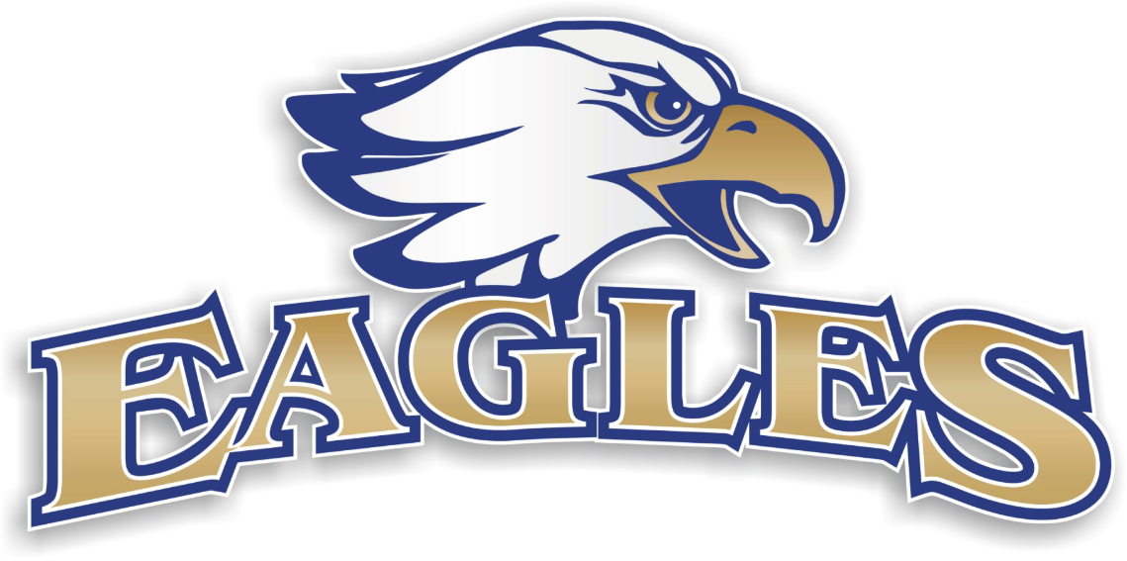
Sponsorship for Eagle Point Youth Football & Cheerleading
Dear Local Business,

Eagle Point Youth Football and Cheer, is a Youth Football Association that has served the communities of White City, Eagle Point, Shady Cove and surrounding areas for almost 19 years now. In that time we have had over 2,600 kids between 5-14 years of age enjoy the camaraderie and fun that youth sports is all about. Our volunteer staff of coaches and parents work their hardest at teaching kids not only the fundamentals and basics of football and cheer, but also the finer points on what it takes to be a responsible adult, such as hard work, sportsmanship and teamwork. We are entirely a volunteer organization. As such, we are actively seeking sponsorship from the local business community to help support our program. Our league is facing some large expenses for the upcoming season. We have had the great opportunity to add Cheerleading to our program. As you can imagine, the annual cost of equipment reconditioning and replacement is significant, and in the past these costs have been almost entirely covered by the parents of the players via registration fees. We are in need of replacing half our helmets this year and the other half next year. We are actively seeking local sponsorship to help defray these costs to allow us to lower registrations fees and give more parents the opportunity to let their children experience the fun and excitement that youth football can provide. Last year we were fortunate enough to have over 150 kids play and cheer on our 6 different teams consisting of both cheerleaders and football players. Upper Rogue is still encouraging the Tiny Mites division to take off in the Valley. We have been able to field a team the last two years, but other organizations haven’t been able to get the turn out. The 2018 season was a year of great accomplishments for all the kids in each of our divisions. Both our Mighty Mite teams traveled to Autzen to play and had a great experience. Our Junior Pee Wee and Pee Wee teams made it to the Rogue Valley Playoffs. This year sponsors will receive a poster photo of the league which may be displayed in your place of business and listed on our website as a sponsor. You will also be announced at every home game. We are currently offering the following levels of sponsorship, but we would be happy to work with you to explore any and all other options if you so desire.

Patch on Game Jersey Per Team- $1200
Your business Logo placed on the upper left of the game jersey for an entire team. Each team consists of 18 to 28 players.

Practice Jersey Sponsor - $800
Your business name on the back of one of our teams practice jersey for the 2019 season and for the life of the jersey. We have used the last sponsored jerseys for more than 5 years now.

Sandwich Board Sign - $600
Your business name and/or Logo on the Board that will be placed on the Eagle Point Football Field Side line during our Home games for the 2018 Season. (There is between 12 and 16 games per season played on Sunday’s.)

Gold - $500
4’x 8’ banner with your business name and/or logo. It will be prominently displayed at each Eagle Point Youth Football home game (There is between 12 and 16 games per season played on Sunday’s.)

Silver - $150
We will be displaying banners at each home game to recognize our Silver sponsors. You will have your business name/logo displayed on a 4’x8’ banner. There will be a maximum of 10 sponsors per banner.
Thank you for your consideration and continued support! Go Eagles!!
Eagle Point Youth Football and Cheer – 2019 Sponsorship Application
Please return to Eagle Point Youth Football at P.O. Box 1220 Eagle Point Oregon 97524.
Make checks Payable to Upper Rogue Youth Football.

O I would like to become a Game Jersey Patch Sponsor
Please enclose a check for $1200
Company Name: _______________________________________________
Contact Person: ________________________________________________
Phone ____________________ Email ______________________________

O I would like to become a Practice Jersey Sponsor.
Please enclose a check for $800.00
Company Name: _______________________________________________
Contact Person: ________________________________________________
Phone ____________________ Email ______________________________

o I would like to become a Sandwich Board Sponsor.
Please enclose a check for $600.00
Company Name: _______________________________________________
Contact Person: ________________________________________________
Phone ____________________ Email ______________________________

o I would like to become a Gold Sponsor.
Please enclose a check for $500.00
Company Name: _______________________________________________
Contact Person: ________________________________________________
Phone ____________________ Email ______________________________

o I would like to become a Silver Sponsor.
Please enclose a check for $150.00
Company Name: _______________________________________________
Contact Person: ________________________________________________
Phone ____________________ Email ______________________________

o I would like to become a Supporter of Upper Rogue Youth Football.
I have enclosed a check for $5, $10, $20, $50, etc.
Company Name:________________________________________________
Contact Person:_________________________________________________
Phone:_____________________ Email:______________________________

o I would like to be contacted about other ways that I can help Support URYF
(Gift certificates, etc.). Please have someone contact me.
Company Name: _______________________________________________
Contact Person: ________________________________________________
Phone ____________________ Email ______________________________

Thank you for your generous support!
For additional Information contact:
Darrin George President of Eagle Point Youth Football and Cheer
541-200-9116 or Email: georgedarrin@yahoo.com

